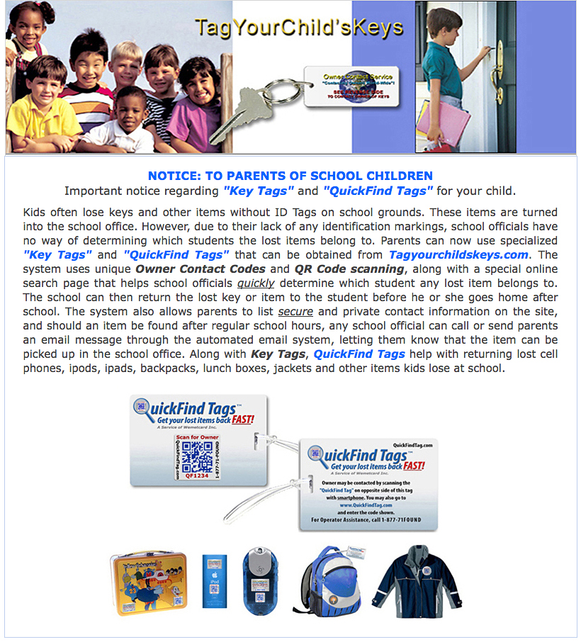

For Parent sign up visit: http://www.tagyourchildskeys.com?a_id=schoolname

